Report on the research activity of the team

Focus of the team
The team of Biodiversity and Conservation Biology focuses on exploring and conserving biodiversity. Our studies thus target the cross-section among ecology, taxonomy, conservation and society. The team has been formed in 2015 and it is structured in four laboratories (Temperate Biodiversity, Woodland Ecology, Ecology of Aquatic Insects and Relict Ecosystems, and Entomopathogenic Nematodes). The four laboratories pursue common as well as their own goals, but routinely share expertise and collaborate on overlapping topics. Their expertise covers wide range of taxa (mainly, but not only insects) and habitats, from freshwaters and wetlands to arid grasslands and forests. While most research activity takes place in the Czech Republic and Central-Eastern Europe, our geographic scope spans to East Asia as well as to tropics.
The team is international, it includes researchers and students from the Czech Republic and numerous, mainly European countries. The team is engaged in broad international collaboration.

Studies of the Laboratory of Temperate biodiversity span across ecology, conservation and society, using primarily butterflies and other Lepidoptera as a model group, and highlighting evolutionary background of studied phenomena. Majority of our results are based on transcending across methodological approaches, from field surveys to advanced molecular and modelling techniques, research fields, from alfa-taxonomy to ecology an biogeography, and groups of participants; we work with amateur entomologists across the country, state conservation officials, NGOs and even business circles.

The Laboratory of woodland ecology investigates various aspects of ecology, biology and diversity of insects associated with woodlands together with processes affecting their habitats and survival. Our research combines entomology, community ecology, landscape and historical ecology, forestry and GIS methods in order to broaden the body of knowledge that contributes to rational, evidence-based conservation of biodiversity. We use mainly beetles as a model group, but we employ multi-taxa approach if appropriate. To facilitate for information flow between the academy and wide the array of stakeholders, we also collaborate with various NGOs, state organizations, land owners and media (see also https://www.oldtree.cz/index.php).

The Laboratory of Aquatic Insects and Relic Environments primarily focuses on ecology, taxonomy and conservation of aquatic insects and other ectotherms. We use laboratory experiments and mathematical modelling to explore e.g. the effects of climate change and other anthropogenic stressors across multiple levels of organization from individuals to communities. We also study taxonomy and phylogeny of both extant and fossil mayflies (Ephemeroptera) and stoneflies (Plecoptera).

The Laboratory of Entomopathogenic Nematodes studies systematics, phylogeny and ecology of insect-parasitic and molluscoparasitic nematodes with a special emphasis on their bacterial symbionts and associates. We also explore options for use of selected nematodes as biological control and develop the methods of nematode mass rearing for the large-scale applications. Another line focuses on the use of molecular markers for various aspects of biology and ecology in broad range of invertebrate organisms.

Research activity and characterisation of the main scientific results

Main research areas and results of the Laboratory of Temperate biodiversity:
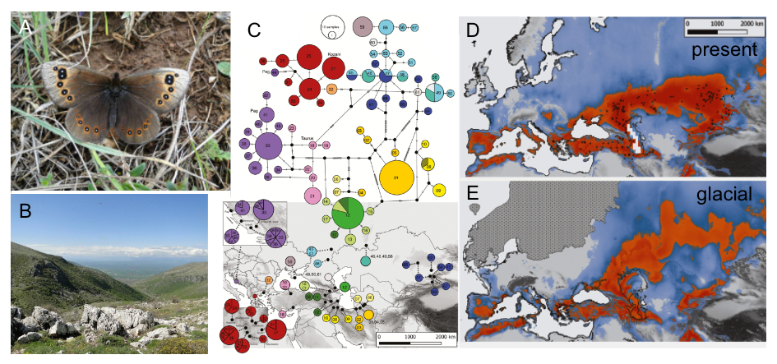
- Applied conservation problems: We studied the effect of wider landscape on faunas of protected areas (Bartoňová et al., 2016, Ecography 39, 456-464), the effect of grain size in farmland landscapes on butterflies and moths (Konvička et al., 2016, J. Insect Conserv. 20, 1113-1118; Novotný et al., 2015, J. Appl. Entomol. 139, 390-400). Using a multi-taxa study, we illustrated the role of farmland edges as biodiversity refuges (Šálek et al., 2015, Basic Appl. Ecol. 16, 714-725). To disclose traits and gradients associated with rarity and vulnerability and to facilitate for deeper understanding of ecological processes affecting moths, we generalised on life history traits analysis of Central European moths (Potocký et al., 2018, Insect Conserv. Divers. 11, 493-505). We broadened the scope of our interests to Mediterranean region, global biodiversity hot-spot still under-researched by insect conservation. We showed that forest encroachment homogenises butterfly communities of the Balkan Peninsula (Šlancarová et al., 2016, Plos One ‏11, e0152026), analysed butterfly fauna of Portuguese woodlands (Šlancarová 2015, J. Insect Conserv. 19, 823-836), and documented factors responsible for high papilionid diversity in Greek Thrace (Šlancarová et al., 2015, J. Nat. His. 49, 1825-1848). We also carried out detailed study of habitat requirements of the continental steppe relict Proterebia afra (Bartoňová et al., 2017, J. Insect Conserv 21, 559-571). Extending our interest to larger scales, and international cooperation by team members, resulted in participation in new checklist of European butterflies (Wiemers et al., 2018, Zookeys, 811, ‏ 9-45). We also investigated the effect of climate change on biotic assemblages. Using a global species distribution database we showed that flight periods in temperate butterflies are not monotonously postponed towards North, but depend on their life strategies and various other factors (Faltynek Fric et al., 2020, Ecol. Let. 23, 172-180).
Fig. 1. a) Proterebia afra and b) its habitat in Greece; c) Mitochondrial phylogeographic patterns of P. afra in the Palaearctic steppes, TCS haplotype network of the 67 haplotypes detected; Species distribution models showing the climatically suitable areas for Proterebia afra (d) today and (e) the Last Glacial Maximum (~22,000 b. p.).

- Ecology and conservation of European fauna in evolutionary contexts: This topic represents the principal shift during the period. As part of an international team, we contributed to disclosing evolutionary history of cold-adapted butterfly genera Erebia (Pena et al., 2015, Biol. J. Linn. Soc. 116, 449-467) and Oeneis (Kleckova et al., 2015, Mol. Phyl. Evol. 92, 225-265). Detailed phylogeographies of the conservation priority species Euphydryas aurinia (Junker et al., 2016, Plos One 10, e0142282; Korb et al., 2016, Syst. Entomol. 41, 441-457). A pioneering work was studying the importance of quaternary climatic events for butterfly species across the entire Holarctic region (Eurasia + North America) (Marešová et al. 2019, Plos One 14, e0214483). Bartoňová et al. (2018, Biol. J. Linn. Soc. 125, 867-884; 202, Conserv. Genet. 21, 561-571) showed that alteration of glacial cycles influenced also fauna of arid steppes.
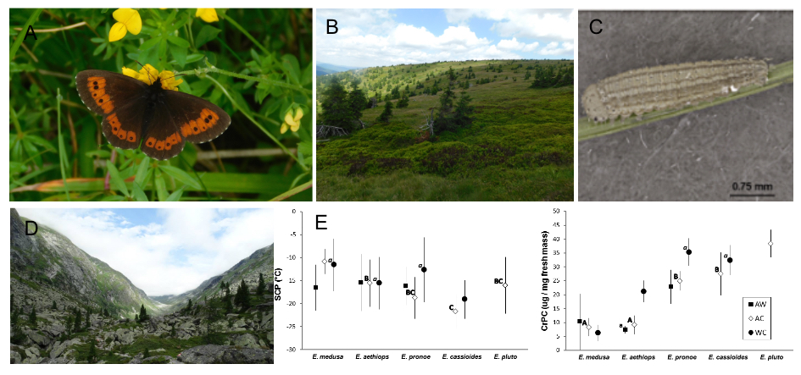
- Cold-adapted species of northern or mountain environments: We participated in disclosing phylogeography pattern in the circumpolar Colias palaeno, associated with bog habitats in temperate region (Kramp et al., 2016, Biol. J. Linn. Soc. 119, 1068-1081). Using the model system of the subalpine butterfly Erebia epiphron in middle high mountains, we showed that warming of the last two decades caused earlier onset and longer duration of flight period but lower peak abundances (Konvička et al., 2016, Konvička, Eur. J. Entomol. 113, 295-301). Klečková et al. (2015, Eur. J. Entomol. 112, 114-119) presented the first quantitative analysis of biennial life cycle of Erebia euryale across Central European mountains. Several studies targeted ecophysiology of high-altitude insects overwintering, demonstrating high diversity of overwintering strategies in cold-adapted genera Erebia (Vrba et al., 2017, Eur. J. Entomol., 114, 470-480) and Colias (Vrba et al., 2017, CryoLetters 38, 330-338).
Fig. 2. a) Photograph of Erebia euryale ; b) Jeseníky Mts.biotope; c) Erebia aethiops first instar larva with scale; d) Biotope in the Alps; e) Interspecific differences (means ± standard deviations) in the super cooling points (SCP – Plot A) and total cryoprotectant concentrations (CrPC – Plot B) in overwintering larvae of Erebia butterflies subjected to one of three treatments (AW – AutumnWarm, AC –AutumnCold, WC – WinterCold).
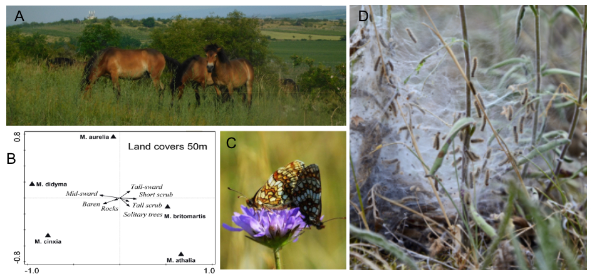
- Effects of trophic rewilding: Current absence of entire trophic guilds, namely megaherbivores and megacarnivores, is a factor behind dependency of a many taxa on human-managed landscapes and habitats. With land use modernisation, large portion of native biodiversity is losing even these essentially surrogate habitats. Return to preindustrial conditions in agriculture and forestry is impossible. But large stretches of land are becoming available, and regional returns of early Holocene, or even interglacial, ecosystem dynamics is becoming an option, at the very least for selected protected reserves (Vodičková et al. 2019, J. Nature Conserv, 52, 125755). Further understanding related to refaunation activities was gained by work with coprophagous beetles and flies. Buse et al. (2015, Biol. Conserv. 187, 112-119), in pan-European analysis, showed the importance of grazing continuity for coprophilous beetles richness. Sladecek et el. (2017, Plos One 12, e0170426; and 2017, Entomol. Sc. 20, 111-121) described spatiotemporal segregation in coprophilous insect assemblages, bringing evidence for habitat filtering structuring the communities.
Fig. 3. a) Exmoor ponies grazing in the Podyjí National Park; b) RDA ordination biplots showing the effects of land covers on distribution of adult captures of five species of checkerspot butterflies, occurring at xeric grasslands of Podyjí National Park; c) Mating Melitaea aurelia; d) Nest of checkerspot butterflies larvae.

Main research areas and results of the Laboratory of Woodland Ecology:
- Veteran trees and dynamics of woodland habitat: Veteran trees are keystone structures sustaining biodiversity of wooded ecosystems. In our effort to understand dynamics and importance of this critical and highly threatened habitat structures, we inventoried ~ 12,000 veteran trees over 124 km2 of floodplain woodlands in the SE tip of the Czech Republic (Miklín et al. 2015 J.Maps 13: 291-299). This data later served as base for delimitation of several protected areas by the Czech Ministry of Environment. And using current and historical aerial photos, we investigated how forest structure in 1930s affected current presence of the veteran trees and important saproxylic beetles associated with them (Miklín et al., 2018, Div. Dist. 24: 208–218). We also showed that veteran trees are important to other arthropod than just saproxylic beetles (Sebek et al., 2016, For. Ecol. and Management 380: 172-181). To allow for planning of conservation management of veteran trees, we investigated their age and growth patterns (Altman et al.. 2016, For Ecol Management 380: 82-89). To shed light on the mechanisms behind the importance of veteran trees and the conditions enabling veteran tree specialists to exploit smaller trees, we investigated local patterns of tree use by a typical veteran tree specialist, the great capricorn beetle (Cerambyx cerdo), at several localities where this beetle exploits oaks of large (~1.5 m), medium (~0.75 m) and small (~0.25 m) diameters (Platek et al., 2019, Eur. J. Entomol. 116: 64-74).
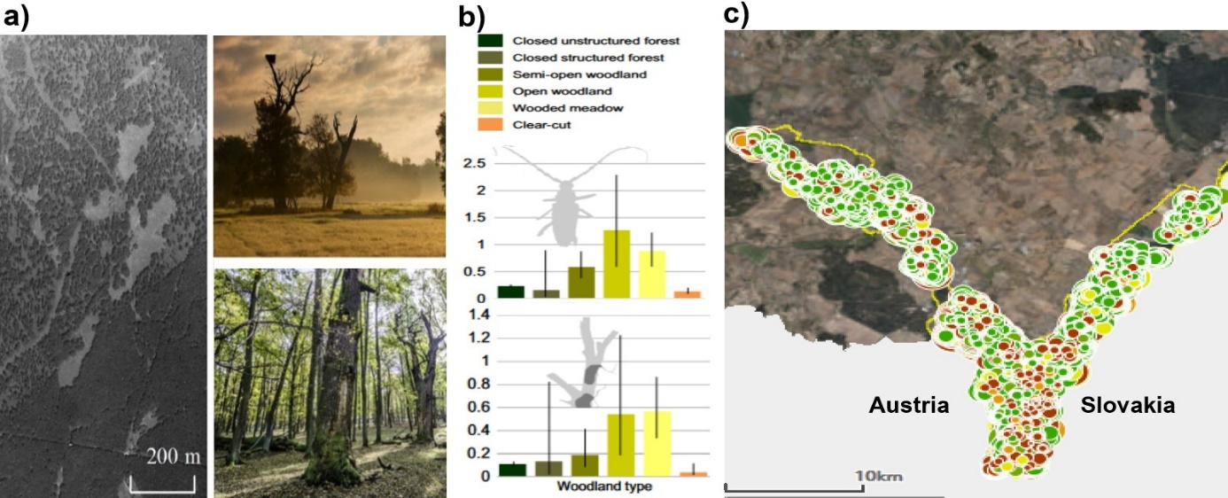
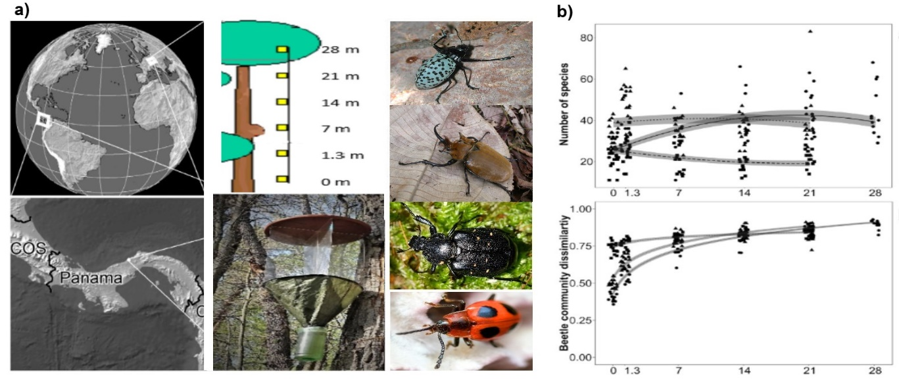
- Insects and ecological gradients: Patterns of insect distribution along various gradients are a hot topic of current ecology. We participated on a study investigating patterns arthropod distribution in tropical forest in Panamá based on data from the large collaborative poject IBISCA (Basset et al. 2015 PLoS ONE 10(12): e0144110). Using complementary data collected in Czechia, we investigated patterns of fine-scale vertical distribution of saproxylic beetles in temperate lowland and montane forests (Weiss et al., 2016 PLoS ONE 11: e0149506; Procházka et al., 2018, Ins. Cons. Div. 11: 534-544). We lead a study comparing patterns of vertical distribution of saproxylic beetles between tropical and temperate forest (Weiss et al. 2019 For. Ecol. and Management 444: 50-58). We also participated on a study investigating host specificity of phytophagous insects across the Globe (Forister et al., 2015, PNAS 112: 442-447).
Fig. 4. Veteran trees, threatened beetles and forest history. a) Aerial picture of woodlands in the SE Czechia from 1936; examples of open and closed forest. b) Current density of trees with Cerambyx cerdo and hollowed trees in stands with closed canopy depend on canopy closure of the stands nearly century ago (1930s). c) Interactive map of veteran trees (~ 12,000 trees mapped)
Fig. 5. Vertical stratification of saproxylic beetles in one tropical and two temperate forests. a) Location; schema of sampling design; flight intercept trap; examples of model organisms. b) Temperate montane forest were species poor in all heights, temperate lowland forest had nearly constant numbers of species, while species numbers were low near ground but increased rapidly towards upper canopy in the tropics.
- Conservation Management: Absence of adequate disturbance regimes often threatens biodiversity in protected areas. We performed, or participated on several studies investigating multitaxa responses to various disturbance regimes in various habitats. In a large scale, manipulative experiment in core zone of a national park, we showed that number of threatened taxa benefits from active interventions aimed at decreasing forest canopy closure (Sebek et al. 2015. For. Ecol. Management 358, 80-89; Lanta et al., 2019, For. Ecol. Management 448 : 94-103). Using the mulitaxa approach, we also showed how various disturbance regimes affect biodiversity in grasslands (Bonari et al., 2017, Agriculture, Ecosystems and Environment 246: 243-252) and postindustrial areas (Řehounková et al., 2016, Environmental Science and Pollution Research 23: 13745–13753; Tropek et al. 2016 Environmental Science and Pollution Research 23: 13653–13660).
- Biology and genetics of threatened species: We started genetic studies of threatened saproxylic beetles. To allow for investigations of finer patterns, we developed microsatellite markers for some internationally protected and important model species, including the hermit beetle (Osmoderma barnabita) (Basiita et al., 2016, Cons. Genetics Res. 8: 85–87). We used the markers to investigate differentiation of the Alpine longhorn (Rosalia alpina) populations in the Central and SE Europe (Drag et al., 2015, Biol. J. Linnean Soc. 116: 911-925), and published whole range phylogeography (based on nuclear and mitochondrial markers) of this species (Drag et al. 2018, J. Biogeogr. 45: 2631–2644). We also used genetics to detect introduced and native populations of the great capricon beetle (Cerambyx cerdo) (Drag & Cizek, 2015, Cons. Genetics 16: 267-276). Using radiotracking, we investigated movement patterns of the capricon beetle (Drag & Cizek, 2018, J Ins Behaviour 31: 138–143). Further studies include habitat preferences of several thereatend species including the highly threatened ground beetle Carabus nitens (Volf et al., 2018, J. Ins. Cons. 22: 321–328), the Alpine longhorn (Rosalia alpina) (Castro et al., 2019 Animal Biodiversity and Conservation 42.1: 59-63), the wrinkled bark beetle Rhysodes sulcatus (Kostanjšek et al., 2018, Ins. Cons. Div. 11: 545–553), and the violet click beetle (Limoniscus violaceus) (Gouix et al., 2015, Ins. Cons. Div. 8: 418-427). A collaborative effort resulted publishing list of beetles associated with primeval forests in Central Europe (Eckelt et al., 2018, J. Ins. Cons. 22: 15-28).
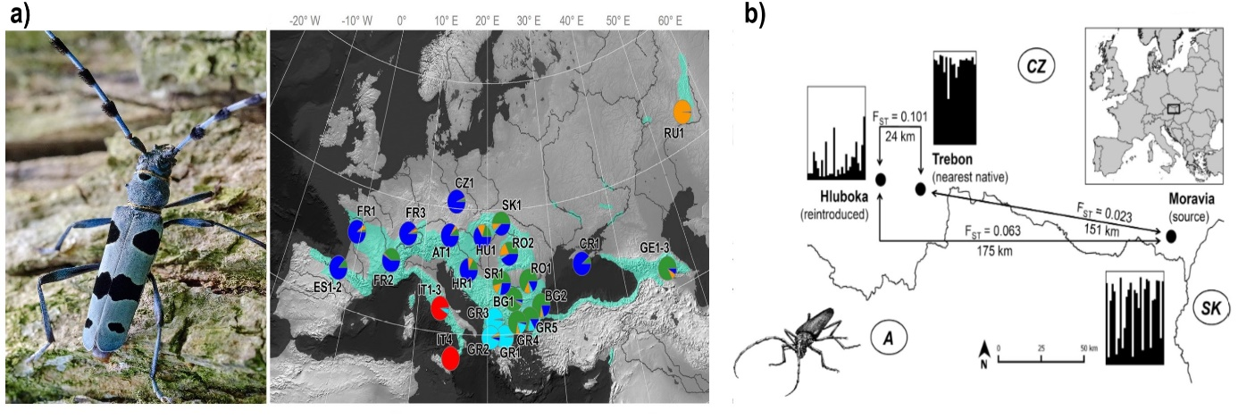
Fig. 6. a) Whole range phylogeography of Rosalia alpina showed highest genetic diversity of the species is associated with Southern Balkans; the pattern is typical for many organisms associated with broadleaf forests. b) A population of Cerambyx cerdo from Hluboka is substantially more related to distant populations form SE Moravia than to the population form nearby Trebon. This indicates recent translocation of individuals from Moravia to Hluboka, where the beetle went extinct in the mid 20th century.
Main research areas and results of the Laboratory of Aquatic Insects and Relic Ecosystems:
- Impacts of climate change on aquatic insects and other ectotherms: Our research has yielded several important results supported by empirical experiments and theoretical modelling. We published the first analysis of community-level effects of declining individual body sizes, which is a ubiquitous response to warming in ectotherms. This work showed that temperature-driven changes in body size can alter existing predictions on the effects of climate warming on food webs, and identified ecosystems and environmental conditions under which changes in body size have most profound effect on food web dynamics (Sentis et al. 2017, Ecology Letters 20, 852-862). Our novel combinations of experimental studies coupled with numerical modelling of predator-prey dynamics further demonstrated that (i) predator diversity and environmental change such as warming can substantially modify the strengths of trophic and nontrophic interactions (Sentis et al. 2017, Global Change Biology 23, 2629-2640) and (ii) acclimation to higher temperatures can substantially alter predator-prey dynamics and buffer against climate change (Sentis et al. 2015, Global Change Biology 21, 3290-3298). We also developed a novel method to quantify variation in temperature dependence of individual development across ontogeny and showed that the so-called developmental rate isomorphy concept is not as universal as previously thought (Boukal et al. 2015, PLoS ONE 10, e0129341). We used these findings together with an extensive literature review to develop a general framework linking biotic responses to climate change across individuals, populations and communities. In that study we outlined the main theoretical concepts used to characterize the effects of warming on insects and other ectotherms, provided examples of key theoretical and empirical studies, and outlined key questions and knowledge gaps for future research (Boukal et al. 2019, Curr. Opin. Insect Sci. 35, 88-95).
Fig. 7. A. We have used laboratory experiments and mathematical models to explore the effects of warming on individuals, species interactions and food web stability; B. Our experiments with combinations of different predatory aquatic insects provided novel insights into multiple predator effects on prey and on the dependence of trophic and non-trophic interactions on temperature.
- Trophic interactions in aquatic insects and beyond: We compared existing methods to quantify multiple predator effects that arise when the combined effects of predators on their shared prey do not equal the sum of their individual effects, and used numerical simulations to provide guidance for future empirical studies trying to quantify multiple predator effects (Sentis & Boukal 2018, Scientific Reports 8, 11787). Using laboratory experiments, we also tested how common biotic and abiotic factors jointly modify the strengths of trophic interactions and energy transfer that underpin the structure of food webs. In a study based on odonate larvae as a model system, we showed that predation risk and habitat complexity can alter interaction strength and metabolic rates and both factors should be considered to better understand and predict the effects of environmentally driven variations on local populations and communities (Kolář et al. 2019, Freshwater Biology 64, 1480-1491).
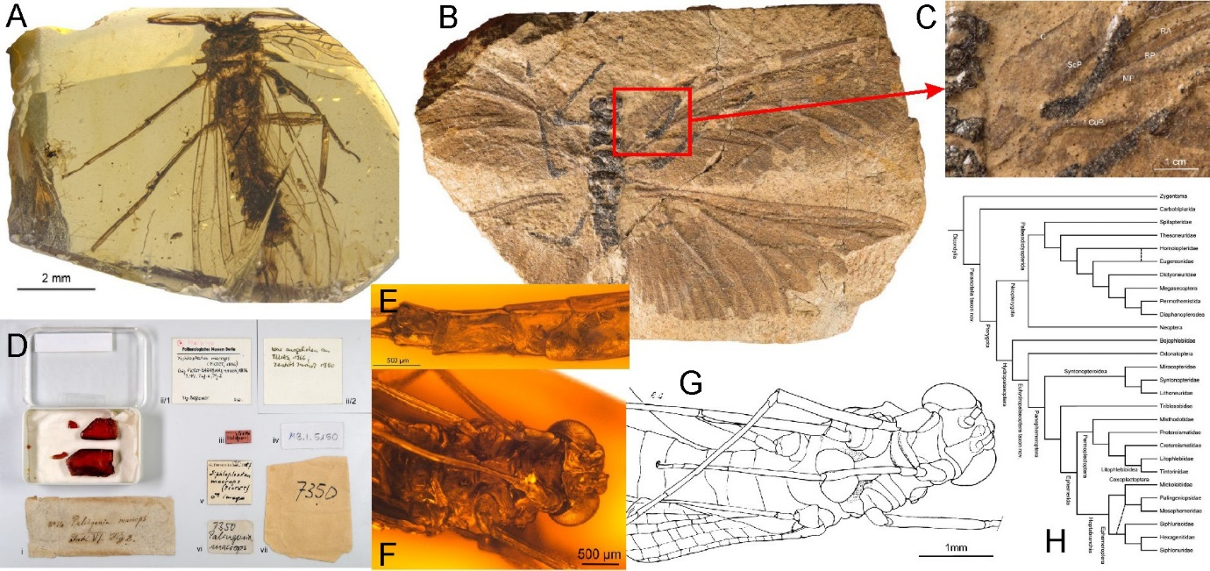
- Research on fossil aquatic insects: We provided important insights on the phylogeny of basal winged insects and to understanding of insect evolution (Sroka et al. 2015, J. Syst. Palaeontol. 13, 963-982). We also worked intensively on various fossils from the Cretaceous Burmese, Eocene Baltic and Miocene Dominican ambers. We discovered several new taxa including a new evolutionary lineage at the stem of infraorder Systellognatha and the first stonefly larva in the Burmese amber, thereby contributing to the reconstruction of the Cretaceous palaeoenvironment (Sroka et al. 2018, PeerJ. 6, e5354).
Fig. 8. A, Lapisperla keithrichardsi, one of the Cretaceous stoneflies described by our team; B, Bojophlebia prokopi, a keystone fossil from the Carboniferous, which we redescribed and used for elucidating evolution of early pterygotes; D-G, material and body structures of the mayfly genus Siphloplecton from the Eocene Baltic amber; H, phylogeny of Palaeopterous insects including fossil lineages.
- Research on recent aquatic insects: We worked on inventories and taxonomy of mayflies , focusing predominantly on the Caucasus Mountains and surrounding area, as an important hotspot of biodiversity (e.g. Hrivniak et al. 2018, Zootaxa 4500, 195-221; Sroka et al. 2019, Zoosystematics and Evolution 95(1), 1-13; Sroka et al. 2019, ZooKeys 872, 101-126). These studies resulted in descriptions of new species andform a basis for a forthcoming broader phylogenetic research aimed at evolutionary processes involved in the formation of local unique mayfly fauna.
Main research areas and results of the Laboratory of Entomopathogenic Nematodes:
- Nematode ecology with new qPCR-based methods: We studied various questions of entomopathogenic nematode (EPN) ecology, distribution and interactions with other organisms using a novel approach of real-time qPCR. We showed competition for insect cadavers exists between entomopathogenic and free living nematodes (Campos-Herrera et al., 2015, Plant Soil 389, 237-255) and that some facultatively parasitic nematodes act as facultative kleptoparasites which can readily explain the low EPN numbers in field samples (Campos-Herrera et al., 2016, J. Invertebr. Pathol. 132, 216-227). We also developed a qPCR-based method for the detection of molluscoparasitic nematodes (MPN) in soil and host tissues. The method represents a new tool to unravel the ecology of nematode-slug complexes (Jafffuel et al., 2019, J. Invertebr. Pathol. 160, 18-25).
Fig. 9. a, b: Estimation of the number of infective juveniles (IJs) in soil samples using qPCR experiments. a Augmentation experiment with 3, 10, and 100 IJs of various EPN species. A-F: Competition experiments between entomopathogenic nematodes (EPNs) and Oscheius spp. Addition of 3 infective juvenile (A–C) and addition of 20 infective juvenile (D-F) (IJs) of either H. megidis (Hm) or/and S. kraussei (Sk) alone or in combination with O. onirici (Ooni) or/and O. tipulae (Otip). Pie graphs above each bar show the proportion of EPN and FLN over the total progeny per cadaver. Additionally, the putative identity of each of the cadaver defined by color (red, H. megidis; dark brown, S. kraussei) is shown in pie graphs below the corresponding treatment in axe ‘‘x”.

- Nematode diversity and phylogeny: We found that the most important genetic marker in EPN systematics, the Internal Transcribed Spacer (ITS) displays larger variability within nematode individuals than between some established steinernematid species. Our results thus significantly affected the systematics and phylogenetic reconstructions of steinernematid EPN (Půža et al., 2015, BioControl 60, 547-554). Our studies in EPN and MPN systematics significantly contributed to our understanding of their diversity by discovering of 5 novel EPN species, and 5 MPN species, with important redesricption of Alloionema appendiculatum (Nermuť et al., 2015, Nematology 17, 897-910). In our recent paper we documented co-cladogenesis of bacterial symbiont Xenorhabdus indica and its steinernematid nematode hosts (Bhat et al. 2019).
Fig. 10. Co-phylogeny of Xenorhabdus bacteria and their steinernematid hosts. a: Tanglegram showing correspondence between Xenorhabdus sp. CS31 and related Xenorhabdus spp. (right) and their nematode partners (left). Associated pairs are linked by a grey line. B. Phylogenetic relationships of Xenorhabdus sp. isolated from Steinernema pakistanense (CS31) with other closely related species of Xenorhabdus, based on analysis of recA and gyrB gene sequences. The percentages of replicate trees in which the associated taxa clustered together in the bootstrap test (1000 replicates) are shown next to the branches. Branch lengths indicate evolutionary distances and are expressed in units of number of base differences per site.

- Applied research: We assessed the possibility of the use of entomopathogenic nematodes for the control of the bulb mite Rhizoglyphus robinii (Nermuť et al, 2019, Biol. Control 128, 102-110). In another study we investigated whether the slug parasitic nematode A. appendiculatum could be used in the control of noxious slugs Arion spp (Nermuť et al. 2019, BioControl 64,697–707). We also indentified the best of method of DNA extraction for taxonomic identification of early developmental stages of forensically important flies (Calliphoridae and Sarcophagidae). It was adopted for the routine work at the Department of forensics of the Institute of Criminalistics, Prague (Olekšáková et al., 2018, Mitochondrial DNA Part A 29 : 427-430).

Cooperation within international research area
Laboratory of Temperate Biodiversity: The range of cooperating institutions mirrors our principal orientation to temperate/Holarctic regions. We closely cooperate with colleagues in North America (e.g., Z. Faltýnek-Fric visit to Alaska, funded by Fulbright foundation) and Russia (Altai State University, Barnaul), as countries crucial for understanding large-scale Quaternary processes. Our students and doctoral students regularly visit cooperating institutions in Germany (Thomas Schmitt, Senckenberg German Entomological Institute), Austria (Jan Christian Habel, University of Salzburg), Sweden (Niklas Wahlberg, Lund University) and Greece (Vasiliki Kati, Agricultural University Arginio). These cooperations are mirrored in joint publications.
Further cooperations are connected to with wider outreach towards Africa (Makerere University, Uganda; SANBI Cape Town; University of Bamako, Mali) and India (KTHM College, Nashik; Zoological Survey of India, Kolkata). We also cooperate with German public or private institutions either oriented to conservation (Geyer-Dolek) or taxonomy (Witt Museum, Zoologische Staatsammlung, Munich; Hamburg University), UK (British Natural History Museum, London; African Natural History Trust, Leominster), Austria (University of Natural Resources and Life Sciences, Vienna).

Laboratory of Woodland Ecology has a wide network of international and national, often interdisciplinary collaborations. We continue active cooperation with members of the IBISCA consortium (https://odnature.naturalsciences.be/ibisca/) that includes >100 experts in tropical biodiversity from > 35 scientific institutions around the globe (https://odnature.naturalsciences.be/ibisca/supporting-institutions). We have common research projects and close collaboration with colleagues from France (University of Toulouse; INRAE), Belgium (University of Liege), Poland (Kazimierz Wielki University in Bydgoszcz), Croatia (University of Osijek, University of Zagreb), Ukraine (Uzhhorod National University), Russia (Samara State University, Vladivostok Botanical Garden), Iran (Iran Forest Authority). Recently we established collaboration with a prominent ecological team from Germany (Joerg Mueller and Simon Thorn; Universität Würzburg and Bayerwald National Park) which includes short and long stays of Ph.D. students and postdocs, and common research. There is also range of occasional collaborations with colleagues from Austria (Tiroler Landesmuseen, WWF Austria), Italy (Museo Civico di Storia Naturale, Carmagnola), Spain (ARAID Foundation). On the national level, we closely collaborate with the Institute of Botany, CAS, Ostrava University, Masaryk University in Brno), and numerous other institutions.

Laboratory of Aquatic Insects and Relic Environments maintained intensive collaborations in the Czech Republic and abroad. Apart from a long-term partnership with the Department of Ecosystem Biology at Faculty of Science, University of South Bohemia, we also collaborated on various projects with colleagues from the Faculty of Fisheries and Protection of Waters (University of South Bohemia), Faculty of Science at the Charles University in Prague and Faculty of Science at the Masaryk University in Brno. Our international contacts include long-term and recently established collaborations with Dr. Arnaud Sentis (Aix Marseille University, Aix-en-Provence, France), Dr. Pavel Kratina (Queen Mary University, London, UK), Prof. Robby Stoks (KU Leuven, Belgium), Dr. Arnold Staniczek (State Museum of Natural History, Stuttgart, Germany), Dr. Jean-Luc Gattolliat (Museum of Zoology, Lausanne, Switzerland); Dr. Ren Dong (Capital Normal University, Beijing, China), Prof. David Bilton (University of Plymouth, UK), and many other ad-hoc collaborations.

Laboratory of Entomopathogenic Nematodes cooperates with the University of Neuchâtel (Switzerland), Chaudhary Charan Singh University (India), Instituto Venezolano de Investigaciones Cientificas (Venezuela), Adnan Menderes University, Aydin (Turkey), and Josef Pavel Šafárik University (Košice, Slovakia). On the national level, there is close collaboration with the Institute of Soil Biology (BC CAS), the Police Institute of Criminalistics (Prague) and the Czech University of Life Sciences, (Prague). The joined research includes also working stays and training of the doctoral students from Josef Pavel Šafárik University and Institute of Criminalistics.

HR policy of the team

The team of Department of Biodiversity and Conservation Biology started with substantial share of researchers in or near retirement age in 2015. Two our colleagues, the late Karel Spitzer and Tomáš Soldán, worked till their virtually last moments. Petr Starý, the doyen of aphid parasite research, contributed substantially to research output of the team until his health, unfortunately, prevented him from continuing the scientific work. Others embraced their retirement. Hence, only Vlastimil Růžička still chases his beloved underground spiders and performs methodologically truly pioneering work with our team.

Today, the largest proportion of researchers in the 30-45 age group, so we have brought together young and senior scientists whose research experience has created an innovative, integrative and comprehensive research environment that addresses challenging scientific and environmental problems. Most young researchers carry out their own research projects together with doctoral and undergraduate collaborators.

We encourage young researchers and PhD students to travel for research stays abroad and support their involvement in international collaborations. Every PhD student and postdoc has visited for longer stay and has established collaboration with at least one foreign research institution. Most postdocs and many PhD experienced several such stays. The countries where collaboration has been established during such visits include e.g. Austria, Belgium, Finland, France, Germany, Greece, Poland, Slovakia, Slovenia, Spain, Switzerland, the UK. Each member of the team is encouraged to increase its expertise and the budget of the lab is used to support participation of the members on international workshops and training courses. Field work and field trips (domestic and abroad) are open to participation to anyone interested, most people thus participate on wide range of projects and activities.

The team of the Laboratory of Temperate Biodiversity consists of two experienced scientists (M. Konvička, Z. Fric), two postdoctoral researchers (A. Sucháčková-Bartoňová, P. Vrba), six in-house PhD students, one external PhD student, and three undergraduates. All PhD students are part-time employees of the institution. One part-time technician (J. Beneš) is a skilled lepidopterist responsible for coordinating national butterfly recording scheme. Since the last assessment, some of our colleagues launched their own research teams (R. Tropek), while others left academia either for other employment (M. Zapletal) or for maternity leaves (L. Zapletalová, J. Marešová). The team has balanced gender ratio, our new post-doc A. Sucháčková (former student of M. Konvička) was awarded by Program for Postdoc CAS (PPLZ). The PhD students are both males and females, with a good representation of students from abroad – Russia (N. Ignatev), Republic of India (J. Irungbam, M. Irungbam) and Slovakia (M. Rindos). Leaders of the team are providing good working environment, including support for young families (J. Marešová currently on maternity leave, but we expect that she will re-join our team later on).

The team of the Laboratory of Woodland Ecology consists of a leader (L. Čížek), four postdoctoral researchers (P. Šebek, L. Drag, F. Sládeček, S. Sakaki), seven PhD (two recently defended, another prior defence) and four undergraduate students. All PhD students are (were) part-time employees of the institution funded by institutional and project money. Two of the three technicians (D. Hauck, O. Konvička) are a skilled coleopterists responsible for insect identification and field-work. The team tries its best to balance gender ratio. From male only team a few years ago we have now one female researcher (S. Sakaki), one PhD student (L. Ambrožová), and two undergraduates (P. Kovářová, M. Helclová). Among the PhD students Czech natives prevail, enriched with a German (M. Weiss), a Croatian (F. Kostanjšek) and a Wallachian native to the Czechia/Slovakia borderland (M. Plátek).

The team of the Laboratory of Aquatic Insects and Relict Ecosystems includes head (D. Boukal), three research scientists (R. Hodunko, V. Růžička, P. Sroka), one postdoctoral researcher (L. Hrivniak), four PhD students (A. Csercsa, V. Kolář, D. Öztürk, L. Vébrová) and undergraduate students. All PhD students are part-time employees of the institution funded by institutional and project money. The three technicians are a skilled in laboratory as well as field-work. The team is truly international, as R. Hodunko and L. Hrivniak are Ukrainian and Slovak nationals, respectively. Of the PhD students, one is Hungarian (A. Csercsa) and one is Turkish (D. Öztürk). Two of the PhD students are female.

The team of the Laboratory of Entomopathogenic Nematodes is rather small and under development. It is lead by V. Půža, and further consists of two research scientists (J. Nermuť, M. Žurovcová), a research assistant (J. Konopická), a technician (L. Kropáčková) and five undergraduate students. All the members of the team are females except for V. Půža, J. Nermuť and one undergraduate student. Czech nationals prevail in the team, one undergraduate student is from Austria.

Age structure of the team

DO NOT FILL IN (will be prepared by PERS dept.)

Strengths and weaknesses
The main strengths of the team of Biodiversity and Conservation Biology include (1) young and growing teams of healthy age structure, (2) combination of experimental and modelling work on individual life histories, trophic interactions and community dynamics, (3) wide range of research methods, from molecular to large-scale GIS-analyses; (4) diversity of approaches, from alfa-taxonomy and phylogeography to sociocultural and applied implications; (5) solid expertise in the knowledge of focal groups; and (6) wide cooperative basis, from amateur naturalists through conservation groups and institutions, domestic and international, to high-profile academic institutions.
We build on long tradition in world-class, continuous research on insect ecology and taxonomy. This includes the maintenance of a large datasets and reference collections. Finally yet importantly, our results, as well as data we manage are much wanted and routinely used by general public and governmental administration. This is mirrored by financial sources of our activities that include wide portfolio of numerous basic and applied national and international research grants, and contractual payments.
The main weakness, as we view it, is a low integration of the Team, which is a legacy of its establishment from formerly two departments. Connected to it is relatively low success rate with scientific grants applications in some labs. It is so far compensated by contractual payments from partners (mainly governmental authorities) and participation in applied research projects. This partly applied focus, although societally beneficial, in turn restricts our ability to invest into cutting-edge research, which in turn diminishes the applications success rate. The situation is improving, however, which is evident from increasing share of publications accepted in Q1 and Q2 journals (e.g., Global Change Biology, Ecology Letters, Nature Communications). Further weaknesses are specific to individual laboratories: Too low number of postgraduate students in Laboratory of Entomopathogenic Nematodes, some long-overdue projects by Laboratory of Temperate Biodiversity, etc. We are aware of these, and are doing best to overcome them.

Assessment of the activity plan of the team for the period of 2015-2019
The current team of Biodiversity and Conservation Biology team has been assembled from two laboratories of the Ecology and Conservation Biology team and two formerly belonging to the team of Biosystematics and Ecology. Most aspect of the plans were fulfilled by all four laboratories.
The Laboratory of Temperate Biodiversity, for example, expanded its activities beyond Central Europe, to the Mediterranean, the Alps, and towards Holarctic phylogeography syntheses. Unplanned but successful was also scholarly expansion to African tropics, and to the temperate-tropical transition zone of Indian peninsula. We substantially developed technically (see below – Molecularisation), and conceptually (see papers combining community and molecular approaches, and several papers analysing life history traits). Currently, we are increasingly using GIS technologies in ecological and biogeographic modelling. An important but yet unfinished task was production of new Lepidoptera distribution atlases for the Czechia. The works were hindered by unforeseen changes in the organisation of the recording scheme, and urgent tasks required in terms of cooperation with conservation agencies and NGOs. The Covid-leave, however, allowed major advances in producing these long-awaited books.
The former Laboratory of Saproxylic Insects has been transformed into Laboratory of Woodland Ecology. Its research scope broadened beyond saproxylic insects, it includes wide range of taxa and approaches. We investigated the effect of past landscape changes on the distribution of key habitat structures and umbrella species, and published several papers on the importance of disturbance and connectivity of wooded habitats. The planned landscape scale experiments were performed in Czechia (Podyji National Park) and Austria (in collaboration with WWF Austria). We also investigated phylogeography of the Alpine longhorn beetle, the icon of beetle conservation.
Laboratory of Aquatic Insects and Relict Ecosystems carried out several projects that dealt with the impact of climate change on individual life histories, trophic interactions and community dynamics of aquatic insects and other ectotherms. We also explored taxonomic diversity of selected groups of mayflies (Ephemeroptera) in Asia and Europe (especially Carpathians, Balkans and Caucasus), and studied the taxonomy and morphology of fossil mayflies and stoneflies (Plecoptera) with implications for the evolution of insect morphology.
The Laboratory of Entomopathogenic Nematodes also mostly followed its plan. It successfully worked on detection of endosymbionts in nematodes and their coevolution. It also studied competition of entomopathogenic and facultatively parasitic nematodes. The applied research focused on the interaction of Nematodes with nematophagous and entomopathogenic fungi. Plans to work on nematode-infecting viruses has been abandoned as the investigator of this topic left our team in 2015.

Implementation of recommendations from past evaluation
To avoid the potential problem of incoherent focus, the teams the Ecology and Conservation Biology and Biosystematics and Ecology were restructured, and the current Department of Ecology and Conservation Biology has been formed.
The recommendations included (1) internationalisation, (2) molecularisation, (3) wider cooperation (technical, methodological, conceptual, personal) with other teams within the Institute, and (4) more intensive involvement in applied ecology and conservation issues, improved outreach to general public.

- Internationalisation advanced in all four laboratories. Temperate diversity laboratory now includes 4 foreign PhD students, 2 foreign students were enrolled into Forest ecology, 3 into Aquatic Insects and Relict Habitats. All four laboratories have strong international cooperation and regularly publish with colleagues from abroad.
- Was generously fulfilled. While 5 years ago, molecular approaches were rare within the team, now they represent a bulk of production and include broad fields from alpha-taxonomy (A. Sucháčková, Z. Faltýnek Fric, M. Rindoš, J. Irungbam, V. Půža), biogepraphy (Z. Faltýnek Fric, L. Drag, A. Sucháčková, L. Hrivniak, J. Marešová) to applications in conservation and ecology (L. Drag, A. Sucháčková, Z. Faltýnek-Fric, M. Konvička).
- Although conservation have stood for long in our focus, all the concerned laboratories further deepened this. For instance, the Laboratory of Woodland Ecology is deeply engaged in various conservation issues. We had a common conservation and research oriented project with Birdlife Czech Republic, and Birdlife Slovakia, as well as WWF Austria, we have deep collaboration with the Podyjí National Park. Three of our laboratories tightly collaborate with the Nature Conservation Agency of the Czech Republic, and our research, data and inventories served as base for numerous management decisions and delimitation of several protected areas.
- This formerly major weakness was also overcome. We collaborate, e.g., with Department of Analytical Chemistry (butterfly larvae cold hardiness – Dr. Šimek, Dr. Zahradníčková). Dr. Sucháčková works partly with Dr. Matos (Laboratory of Molecular Ecology and Phylogenetics), whereas our two “alumni” now with in other teams, Dr. Lipárová (Šlancarová) and Dr. Klečková continue collaboration with us. We further developed regular collaboration with Faculty of Science, University South Bohemia (prof. Nedvěd – insect cold hardiness, prof. Prach – biodiversity of industrially excavated and restored peat bogs, Dr. Grill – GIS applications in biogeography and ecology.

Activity plan of the team for the period of 2020-2024
Laboratory of Temperate Biodiversity aims to continue developing its major strength – multidisciplinary of approaches combined with detailed background knowledge and access to strong data on our focal study groups (butterflies, moths), close cooperation with conservation-oriented agencies, NGOs and general public, and long-term interests in cultural and societal outreach of insect conservation. Thus equipped, we plan to develop the following fields.
1) Inventory and analyses of Czech Republic faunal changes, continuation of recording/monitoring schemes, and preparing several – long awaited – publications, including books.
2) Scholarly evaluation of long-term (20 years) species-specific and site-specific conservation programmes efficiency, emphasising much discussed global climatic change, but also correlates of agricultural/industrial transitions, impacts of EU policies, and – newly – possible societal changes connected to Covid pandemics.
3) Monitoring and experimental studies of impacts of large herbivores trophic rewilding on biotic communities. We view refaunation of “incomplete” European ecosystems as a major avenue in conservation, truly the Donlan´s et al. (2006) “optimistic agenda for 21st century”. Butterflies appear as excellent pivotal model group, but we will follow the rewilding impacts across trophic strata, animal groups and ecosystem functions, all this in cooperation with other departments of the Institute, but also with University of South Bohemia, and concerned NGOs.
4) Evolutionary and historical aspects of ecological processes and faunas formation. We will continue in international projects focusing on Lycaenidae (family level), Pieridae (Colias, Eurema, Belenois) and Satyrinae (Erebia) butterflies. Projected faunal change will be studied using migratory butterflies and moths (e.g., Agrius convolvuli), and widely distributed pests (Lymantria dispar, L. monacha, Sphinx pinastri).

Laboratory of Woodland Ecology will continue to investigate long-term changes of wooded habitats, effects of their management and use on biodiversity. We would like to focus on the importance of habitat connectivity and continuity to woodland biota. We will expand our program of community ecology of saproxylic beetles across temperate Europe and Asia to test generality of patterns observed in Central Europe. High diversity and cryptic habits of saproxylic beetles are the main reasons that even such basic information as feeding habits is unavailable for numerous taxa in Europe. This complicates assignment to feeding guilds and thus partly compromises various ecological analyses. We will employ analyses of stable isotopes to assess feeding habits of our main model group, saproxylic beetles. Organisms associated with veteran trees are considered threatened for several decades. Climate change has great potential to further increase mortality of veteran trees that are notoriously difficult to replace due to their long development. We will search for approaches to substitute this crucial habitat. Further, we will also continue our outreach to conservation community and general public.

Laboratory of Aquatic Insects and Relict Ecosystems will continue to investigate the impact of climate change on individual life histories, trophic interactions and community dynamics of aquatic insects and other ectotherms. We will extend our focus on other important anthropogenic stressors including various pollutants (heavy metals, pesticides, active pharmaceutical compounds, microplastics). To this end, we will use access to the newly established array of heated outdoor mesocosms at the University of South Bohemia, which provide a unique experimental facility in the Czech Republic and matches similar state-of-art facilities across Western Europe and North America.
Based on our long-term sampling and taxonomic research of mayflies in the Caucasus Mountains, we plan to reconstruct their diversification process and clarify the role of various factors involved. We also plan to continue work on the phylogeny of basal pterygotes, newly evaluating several keystone fossils of stem-mayflies. Based on the rich material of fossil mayflies from key Mesozoic deposits of Europe, Asia and S. America, we plan to critically evaluate all evidence on the diversity of Ephemeroptera, and establish new taxa.
We have also digitized unpublished data on long-term population trends of nocturnal Lepidoptera collected by the late K. Spitzer and plan to use the data in collaborative studies.

Laboratory of Entomopathogenic Nematodes will advance with the research of multitrophic interactions of entomopathogenic nematodes. We will to continue studies in systematics and phylogeny of entomopathogenic, insect parasitic and molluscoparasitic nematodes. Within evolutionary genetic studies, we plan to broaden and modernize the spectrum of used methods for studies of evolution and populations genetics of EPNs. More specifically, we would like to add to our evolutionary studies of EPN functional analyses (i.e. focus on the candidate genes involved in the parasitic lifestyle chosen upon the comparative transcriptomics, verification of their importance by RT-PCR, RNAi and subsequent biostatistical analysis).
Within applied research, we plan to test the use of EPNs for the control of insect pests (Colorado Potato beetle and spruce bark beetle) and the use of secondary metabolites of bacteria against noxious organisms (e.g. Arion spp. slugs). Furthermore, we plan to study biocontrol potential of several new species of molluscoparasitic nematodes of the genus Phasmarhabditis, including methods of their mass rearing.

Pedagogical activity

Overview of semestrial lectures, seminars and courses

Name of university | Lectured by | Title of the lecture | Number of semestrial lectures, seminars and courses 2015-2019
 |  |  | Bachelor | Master | Doctoral
University of South Bohemia | Konvička | Conservation biology (CZ) |  | 5
University of South Bohemia | Konvička | Conservation biology (EN) |  | 1
University of South Bohemia | Konvička | Diversity of life | 5
University of South Bohemia | Konvička | Introductory zoology | 5
University of South Bohemia | Konvička | Field course alpine ecology |  | 3 | 2
University of South Bohemia | Konvička | Diversity and conservation of European fauna |  | 3
University of South Bohemia | Konvička | Animal conservation |  | 2
University of South Bohemia | Faltýnek Fric | Systematic entomology |  |  | 1
University of South Bohemia | Faltýnek Fric | Capture-mark-recapture methods |  |  | 1
University of South Bohemia | Čížek | Forest ecology  (part) |  | 1
University of South Bohemia | Čížek | Urban ecology (part) |  | 1
University of South Bohemia | Čížek | Plant-animal interactions(part) |  | 2
Prešov Univ. (SK) | Čížek | World ecosystems | 1
Prešov Univ. (SK) | Čížek | Entomology |  | 1
University of South Bohemia | Ambrožová, Kozel, Perlík | Entomology field course |  | 1
University of South Bohemia | Boukal | Animal ecology | 4
University of South Bohemia | Boukal | Evolutionary ecology |  | 3
University of South Bohemia | Boukal | Modelling for ecologists in R |  |  | 3
University of South Bohemia | Kolář | Hydrobiology - Field course |  | 2
University of South Bohemia | Kolář | Zoology chapters on vertebrates |  | 2
University of South Bohemia | Nermuť | Nematodes in biol. pest control |  |  | 1
University of South Bohemia | Žurovcová | Population and evol. genetics |  | 1
University of South Bohemia | Žurovcová | Genetic markers in populations | 1

Supervision of students

Type of study | No. of supervisors | No. of consultants | Theses defended 2015-2019
Bachelor | 16 | 6 | 17
Master | 6 | 5 | 21
Doctoral | 6 | 5 | 9

Participation of PhD students in the outputs
Basically all the PhD students actively participate in team activities, which is evident from their authorship of publications. PhD students from other institutions also come for training and in research team in all main areas. They help to establish our cooperation with their home institutions.

Ambrožová L. – Female, Czech. Dung beetle ecology, obtains own funding and effectively manages scientific work. Author of popular articles, research reports and minor papers, first author of two manuscipts in review; currently on research stay in Germany.
Ignatev N – Male, Russian. Skilful taxonomist and molecular taxonomist, fruitful collaboration with high-profile musea labs in Germany, Russia and other countries. His
achievements include high-quality photography, dissections etc.
Irungbam, J. – Male, Indian. Trained in taxonomy of butterflies and moths, now extending his interests into ecology and phylogeny. Author of several taxonomic papers and Lepidoptera distribution checklists.
Irungbam, M. – Female, Indian. Trained in molecular biology, extending interests to ecology. Co-author of several Lepidoptera distribution papers.
Hrivniak L. – Male, Slovak. Recently defended. Enthusiastic young scientist highly effective in all aspects of scientific work. Involved in numerous projects and collaborations. Several first-authored publications in peer-reviewed journals, and science popularizations.
John V. – Male, Czech. An older fellow, full-time employed in Czech Conservation Authority, external student. His PhD topic, evaluation of long-term insect conservation programs, is complementary with his main job responsibilities. Involved in the TAČR research project.
Kolář V. – Male, Czech. Effective and enthusiastic field- and lab- worker, capable of state of art analyses and paper writing. Involved in numerous research, conservation and monitoring projects, several first-authored publications in peer-reviewed journals, and science popularizations (articles, press releases, activities for general public).
Kostanjšek F – Male, Croatian. Habitat preference and mobility of threatened saproxylic beetles. Field work and R enthusiast, author and co-author of two papers, long work on the third one prevents him from obtaining PhD.
Kozel P. – Male, Czech. Hardworking beetle enthusiast, effective in the field, sample sorting and beetle identification, patiently chews his way through analyses and paper writing. He started unique work on stable isotopes. Author of several faunistic notes, co-author of a recent paper, and the main author of an advanced MS.
Marešová J. – Female, Czech. Molecular biogeographer and ecologist, currently on maternity leave, but already authored one published (PlosOne) paper and one paper accepted for publication (J. Biogeography).
Perlík M. – Male, Czech. Specialist on Aculeate Hymenoptera. Built extensive network of collaborations, co-authored a paper co-author during his Master studies, co-author of a recent paper in Nature communications.
Plátek M. – Male, Czech. Habitat dynamics, habitat preference of saproxylic beetles, Carabidae specialist, active management of protected forests. Recently defended his PhD and works with nature conservation transferring modern conservation biology into practice. Co-author or main author of eight scientific papers.
Rindoš, M. – Male, Slovak. Trained as ecologist, he is now extending his interests into molecular taxonomy (Lymantridae moths) and Hymenoptera. Co-author of an important Ecology Letttes paper.
Sucháčková (Bartoňová) A. – Female, Czech nationality, she gained skills in field ecology, molecular ecology and advanced evolutionary analyses and became valuable postdoctoral researcher. Her achievements include senior authorships in, e.g., Biol. J. Linn. Soc., Conserv. Genet., J. Insect Conserv.
Weiss M. – Male, German. Vertical stratification of insects in forests, first author of three papers and co-author of several others. Defended last year.
Zítek T. – Male, Czech. Dung beetle enthusiast, studying ecology and trophic interactions of coprophilous communities.

Involvement in the joint research centres with universities
DO NOT FILL IN (no official joint research centre exists)

Participation of team members in activities of scientific community

Participation of team members in activities of scientific community

Membership in Editorial boards:

European Journal of Entomology (M. Konvička, D. Boukal); Nota Lepidopterologica (Z. Faltýnek Fric), Nematology (V. Půža).

Academic advisory boards:

Faculty of Sciences, University South Bohemia, adv. board Entomology (M. Konvička, L. Čížek)

Faculty of Sciences, University Ostrava, adv. board Zoology (M. Konvička)

Scientific Council of the Faculty of Science, University of South Bohemia (D. Boukal), Scientific Council of the University of South Bohemia (D. Boukal).

Evaluation committee of excellent scientific results (panel EP10) for the Office of the Government of the Czech Republic (D. Boukal, 2017).

Scholarly organisations and scientific societies:

-Czech Entomological Society (many team members, L. Čížek is member of Board of Trustees)

-Czech Ecological Society (many team members, L. Čížek is member of Board of Trustees)

-International Hymenopterist Society (M. Rindoš)

- Societas Europea Lepidopterologica (Z. Faltýnek Fric, M. Rindoš, A. Sucháčková)

-Lepidopterists’ Society of Africa (Z. Faltýnek Fric)

-Butterfly Conservation Europe – the Institute, represented by our team, represents

Czech Republic in the Organisation

International Organisation for Biological and integrated control (IOBC-WPRS)

- Convenor of the Sub-Group Entomoparasitic Nematodes within (V. Půža)

- Convenor of the Slugs and snails study sub-group IOBC-WPRS (J. Nermuť)

Organized conferences and workshops
5th conference of the Czech Society for Ecology in Ceske Budejovice, 23-25 October 2015 (D. Boukal – main organizer).
Workshop on active management of forest protected areas, international workshop held in Mikulov from 1-5 August 2016 (L. Čížek, co-organizer)
Slug and Snail section and the workshop for slugs and their nematode parasite identification at the IOBC - SIP conference in Valencia, Spain 2019 (J. Nermuť – section organizer)

Invited lectures and earned awards
Z. Faltýnek-Fric – invited lecture at Societas Europaea Lepidopterologica, Dresden.
R. Hodunko - Plenary lecture, Slovak Zoological Society congress “Zoologia 2018”.
V. Kolář - prize for the best paper by a junior author (under 25 years) for his popular science paper on diving beetles in the Ziva magazine (V. Kolar, D. Boukal: Ziva 6/2015, 300-303).
M. Konvička – invited plenary lecture at Deutsche Enomologische Gesselschaft annual conference, Frankfurt a/M
J. Nermuť - invited lecture at International symposium on Entomopathogenic Nematodes and Biological Control. Chengdu, China, 2019.
V. Půža – Invited lecture at 32nd symposium of European Society of Nematologists, Braga, Portugal, 2016; invited lecture at International symposium on Entomopathogenic Nematodes and Biological Control. Chengdu, China, 2019.

Participation in large collaborations
D. Boukal:
Pan-European synthesis of long-term data on biodiversity trends - summarized in a paper lead by F. Pilotto from Umea University and published in 2020 in Nature Communications, to which we contributed long-term dataset on nocturnal Lepidoptera.

L. Čížek + M. Weiss:
We continue active cooperation with members of the IBISCA consortium (https://odnature.naturalsciences.be/ibisca/) that includes >100 experts in tropical biodiversity from > 35 scientific institutions around the globe (https://odnature.naturalsciences.be/ibisca/supporting-institutions).

Z. Faltýnek-Fric:
- Checklist of European Butterflies (PI: Martin Wiemers) – already published, ZF is co-author, has been responsible for selected E. European countries.
- Comprehensive phylogeny of Nymphalid butterlies (PI: Niklas Wahlberg) – major paper under review

M. Konvička + J. Beneš:
Monitoring of European Butterflies – initiative by Butterfly Conservation Europe, led by C.van Swaay. Regular delivery of Czech butterfly monitoring results, participation on analyses and interpretation.
They also organize National Butterfly Transects Monitoring – ca 30 transect walked every 10 days, currently 10th year. Data from both schemes are regularly supplied for international use (Monitoring European Butterflies, several editions of European atlases).

Outreach activities
An undisputed strength of the whole team. It receives our substantial effort as it is our shared view that education and transfer of knowledge is crucial part of our mission. Team members are often interviewed by local and national media on issues such as insects conservation, forest ecology, global change, mountain insects, naturalistic grazing, etc. They regularly participate on various TV and radio broadcasts. During the last 5 years, we published over 50 articles in Czech popularisation magazines (Ochrana Přírody, Veronica, Vesmír, Živa) and webzines (Forum ochrany přírody, Ekolist, and others) as well as in mainstream media. Team members also prepare often widely reported media releases on various research and conservation topics, in broad collaboration with other scientific institutions and societies. Team members regularly give lectures and talks to people from NGOs and state institutions (incl. e.g. Ministry of Environment or the Senate of the Czech Republic), and general public including kids. We also participated in the organization of biology-related contests for high schools (Biology and Ecology Olympics), and popularization events for schools and general public (Researchers’ Night, ‘Open door’ Days, Biodiversity Day, Summer scientific camps etc). See e.g. https://www.oldtree.cz/index.php?page=media&link=6 or https://www.oldtree.cz/index.php?page=publications&link=4&typ=1

J. Beneš and M. Konvička are co-organising Czech Butterflies and Moths recording (currently ca 1 000 000 records), which involves database maintenance, presenting results, but also regular contributions to widely circulating magazines and web pages, and administering social media groups (mainly J. Beneš). Nationally, the data are used by conservation agencies, and during the last 5 years, served for production of two regional butterfly atlases (České Budějovice and Ústí nad Labem regions – J. Beneš, Z. Fric and P. Vrba co-authored the two positively accepted books).
In order to facilitate for transfer modern conservation biology from scientific journals to practice, we also prepare numerous materials to aid evidence based conservation approaches. Czech Ministry of Environment has certified our seven “cookbooks” on conservation management of individual threatened beetle species, one on management of rare moths habitats, and another one on conservation of open woodlands (see https://www.oldtree.cz/index.php?page=publications&link=4&typ=2). We organized well-attended international workshop on this topic and also a field trip to Germany, France and Spain for NGO and state employed conservationists. The main aim was to introduce them to effective and modern approaches to biodiversity conservation.
We have intensive collaborations with several NGOs in the Central Europa. They include Birdlife Slovakia, WWF Austria and BROZ.SK. Among the Czech NGOs, we closely collaborate with Birdlife Czech Republic, and several branches of the Czech Union for Nature Conservation (the largest conservation NGO), Calla.cz. The most intensive and scientifically and educationally fruitful is collaboration with NGO Česká krajina ( = Czech Landscape), a group supervising trophic rewilding of high biodiversity value localities across the Czech Republic by large herbivores. We do also actively interact with numerous landowners and stakeholders.
As an information base for practical nature conservation, we also mapped thousands of veteran trees. The inventory supplied data for some of our publications and its results are available in form of two on-line interactive maps. One concerns ca 12,000 veteran trees in a biodiversity hotspot of south-east Moravia (http://goo.gl/oeBgtn). Another concerns thousands of old pollard trees across Southern and Eastern Moravia (https://kfgg.maps.arcgis.com/apps/webappviewer/index.html?id=4d390794c9ec46b889269e744a8c5222)

